Infection Curve Simulation: Using a Computational Model to Predict the
Impacts of Social Distancing on Viral Transmission

STUDENT ACTIVITIES

Part 1: Pre-knowledge

1. The United States Centers for Disease Control has recommended that Americans take steps to slow the spread of Covid-19. One such step is social distancing. What does the term social distancing mean to you?

2. How have you or others that you know implemented social distancing?

3. Flattening the curve is the goal of efforts to control the spread of Covid-19. Explain your understanding of what is meant by “flattening the curve”.

Part 2: Introducing a Model: NetLogo Simulation

You will be using a model to help you observe how social distancing impacts the spread of disease in a population.
- Watch a short video introducing the NetLogo Model, “Infection Curve Modeling.” Jacob Kelter narrates the video and he created the simulation
- Click here to use the NetLogo Model. https://www.jacobkelter.com/infection-model/

Part 3: Using the NetLogo Model - Read carefully!!!

- Looking at the netlogo model, keep the variables as the default settings. Change only the social distancing% slider and press “Setup” and then “Go”. Allow the simulation to run until it stops.
  - Record your data on the table on the next page for Distancing % as well as your Max Infected % and Time of Peak found below the graph.
  - Press “Setup” again and manipulate the Distance% slider to a new percentage and repeat your data collection for 4 DISTINCTIVELY different Distancing%.
    - Make each Distance% spread out (ranging from 1 - 100) so as to gather the best data.

Data Table:

Distancing% | Time of Peak | Max Infected

INFECTION CURVES: Screenshot your graph from the Netlogo simulation that includes all 4 of your Infection Curves and paste the image here OR sketch a simple graph showing all 4 of your Infection Curves

1. According to your data table above, how does social distancing % affect the Infection Curve?

2. World Infection Rates by country - Use what you have learned about social distancing from the simulation to infer how each country and region has utilized social distancing in an attempt to control their infection rates.
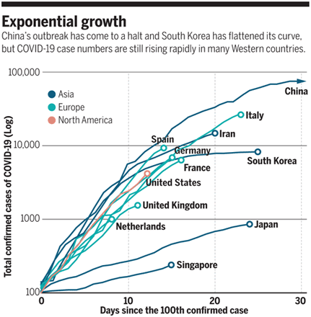
- Examine the infection rate curves for Europe and North America in comparison to Asia (Japan and Singapore). Which countries do you think employed social distancing practices early in an attempt to control the spread of infection? Support your choice with evidence from the graph above.

- Research the actual social distancing policies of Japan and Singapore, including timing of school closing and social greeting norms. How do the policies in these countries differ from the policies in the United States? Give the name of the sources you used.

- Based on what you have found out about Japan’s response to COVID-19, does the graph above give an accurate account of their situation and response? Why or why not?

Possible Students Resources:
Singapore

Early Days of a Global Pandemic

Singapore, Coronavirus Model

Japan

Japan’s Limited Response

Japan’s Crisis Just the Beginning

Coronavirus Japan

Part 4: Analysis/Personal Actions

1. Look back at your answers in Part 1. Explain how your understandings of social distancing and its relationship to flattening the curve have changed. What have you learned about these concepts?

2. How can you use what you have learned in this activity to help slow the spread of the virus in your community? [Some options could be a written response, infographic, create a meme, or a PSA].

3. Social distancing has been the term used popularly in the news, but some have suggested that the term physical distancing is more accurate. What do you think? Which term best conveys the meaning?

