Media Literacy Teacher Guide

Research indicates students think they are much better at evaluating sources of information than they actually are. The goal for this group of activities is to provide some tools that students can use and some practice activities around the COVID outbreak.

- Starting with a KWL style activity. Where do we get our information? How do we know it is factual? What should we do to avoid misinformation?
- The model below, adapted from Maier and colleagues, has been effective in helping students visualize how bias can creep into science information at all stages—from generation through communication and interpretation. It can be shared directly with students alongside discussions. Talking about traditional journalism with reporters/editors being the gatekeepers of information to today’s situation where anyone can communicate information regardless of expertise/ethics/agenda is important.
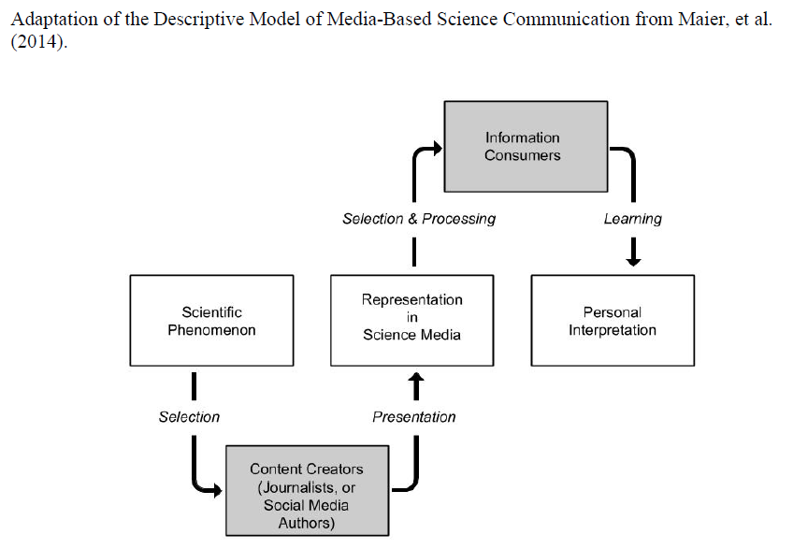

- Defining Bias – Ideally a group discussion with students coming up with their own definitions. In general –the preconceived ideas and judgements through which we view the world.
- Media literacy basics – In the past there was low quantity of information of high quality. Today we live in an instantaneous news cycle consisting of massive quantities of information at all levels of quality. How do we sort through the garbage? We have tools to help students with this important but challenging work.
- Know your Sources of information handout/poster and graphic organizer. This presents themes to look out for with guiding questions about Authors/Audiences, Messages/Meanings, Representation/Reality. Also, it is important to consider Nature of Science ideas around emerging science information and how science works by continuously revising our understandings – this is strength not a weakness, but many special interest groups use the tentative/revision aspects of science as a sign of weakness.
- Specific ways we fall victim to misinformation and bias. We have scaffolded activities to explore these common areas of misinformation
  - Satire
  - Clickbait
  - Hyperpartisan politicized news (extreme left, extreme right)
  - Invented News
- Scavenger hunt for examples of each shown in previous question

