Media Literacy Teacher Guide
Research indicates students think they are much better at evaluating sources of information than they actually are. The goal for this group of activities is to provide some tools that students can use and some practice activities around the COVID outbreak.
This teacher guide aligns with the slideshow titled “Media Literacy Slides”. Teachers are encouraged to read through the slideshow along with the teacher’s guide and adapt the slideshow to best suit their classroom needs.
Note: By the time you are using this resource, many of the links may be several months old. Some of these examples may be irrelevant or out of date due to the rapidly evolving nature of our knowledge about COVID-19. Teachers may feel it is helpful to update links provided with more current examples. However, if teachers choose not to update these links this opens space for a discussion about the tentative nature of scientific knowledge, and the importance of using up to date sources.
Lesson Flow
Activity | Use to... | Skip if...
1. KWL activity | Assess students’ prior knowledge of media literacy practices. | Because of the importance of pre-assessments, it is not recommended that teachers skip this.
2. Bias discussion | Establish a class definition of the term “bias” to ensure everyone is discussing the same concept. | Students already have a uniform definition of bias. This activity is short and may be worth doing anyways.
3. Media literacy basics | Introduce students to the concept of media literacy and its importance. | Students have extensive prior knowledge of media literacy. This may be worth reviewing even if students do have prior experience.
4. Ways we fall for victim to misinformation and bias | Illustrate examples of different information sources and the ways they influence the way information is perceived. | The class has extensive prior knowledge of these common issues in media literacy.
5. Media literacy tools | Students are new to the idea of media literacy, or are familiar, but do not have concrete approaches to assessing information quality. | Students already have concrete media literacy tools from other classes or programs.
6. Media literacy scavenger hunt | Students do not have experience using media literacy tools and evaluating information quality. | Students already have extensive experience evaluating information and source quality.
7. Bonus: Nature of Science | Address why scientific recommendations have changed throughout the COVID-19 pandemic. Teach students about the emerging and tentative nature of scientific knowledge. | This unit needs to be shortened. Students are already aware of this aspect of science.

Lesson Descriptions
- KWL activity (slides 2-4).
  - This activity is designed to help teachers understand their student’s prior knowledge. Teachers are encouraged to use this to guide instruction. This can be done as a bellringer, as homework, or as a closing activity for the day prior to starting the media literacy module. Assigning this as a closing activity is recommended because this grants teachers more time to adjust instruction for their class.
  - (slide 3) Questions to help elicit student thinking during the activity include:
    - Where do we get our information?
    - How do we know it is factual?
    - What should we do to avoid misinformation?
  - (slide 4) Following the activity teachers may create a KWL chart based on class data. There is a template on slide 4 for teachers who prefer to keep track of student responses on their smart board during the discussion.

- Bias discussion (slides 5-7)
  - (slide 6) Teachers should work with their class to establish a common definition of bias before moving forward with this module. Slide 5 is structured to help guide this process. Teacher should collect and record student definitions, add their own definition, and then finally work with the class to establish a common definition. We recommend arriving at a definition that is similar to the one we have listed below
    - the preconceived ideas and judgements through which we view the world.
  - (slide 7) The model below, adapted from Maier and colleagues, has been effective in helping students visualize how bias can creep into science information at all stages—from generation through communication and interpretation. This can be shown on the board to help guide class discussion of how bias can be introduced along the media production and dissemination process. Talking points can include:
    - Talking about traditional journalism with reporters/editors being the gatekeepers of information.
    - Today’s situation where anyone can communicate information regardless of expertise/ethics/agenda is important.
    - The limitations of this model (ex: does not account for the “friend of a friend” sources common on social media).
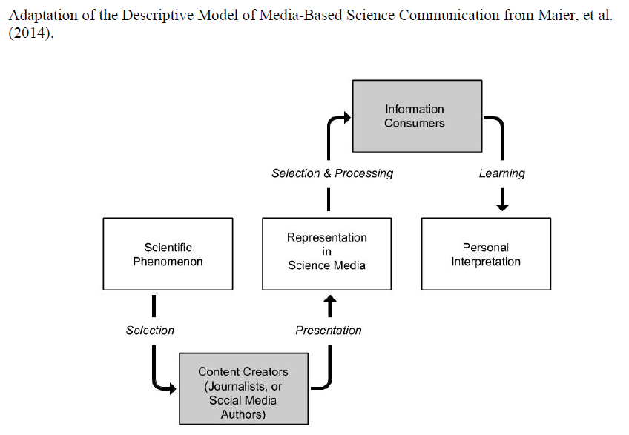

- Media literacy basics (slide 8)
  - This slide is designed to help teachers transition students into learning about how to appraise sources of information for quality and trustworthiness. Talking points are listed below.
    - In the past there was low quantity of information of high quality.
    - Today we live in an instantaneous news cycle consisting of massive quantities of information at all levels of quality.
    - How do we sort through the garbage? The following slides include tools to help students with this process.

- Specific ways we fall victim to misinformation and bias (Slides 8-15)
  - We have scaffolded activities to explore these common areas of misinformation in the coming slides. These examples are provided to help provide context for students.
    - Slide 8 lists four common types of sources that spread misinformation. Slides 9-14 showcase examples of each of these types of sources in the context of misinformation. Slide 15 showcases examples of high-quality information sources.
    - Teachers may allow students to explore these examples at this time, however more time will be devoted to engaging with these materials later. The purpose of this section is to introduce students to these examples before diving into how to recognize them.

- TOOLS (slides 9 and 10)
  - We recommend choosing one of the following tools to help students evaluate the quality of information and their sources. The teacher should select the tool they feel will work best in their classrooms. It may be helpful considering the media specialist at the school to see what tools they have used or recommend.
    - Know Your Sources of information (slide handout/poster and graphic organizer (slide 9).
      - This presents themes to look out for with guiding questions about Authors/Audiences, Messages/Meanings, Representation/Reality. The Know Your Sources of Information Tool is designed to provide students with a resource to refer to when evaluating sources. The Know Your Sources Organizer is provided to help students guide and organize their thoughts when evaluating sources.
    - CRAP TEST (slide 10)
      - The CRAP test is another tool to help students pick apart and analyze the trustworthiness of an article. This format is catchy and focuses on more concrete measures of source quality such as how recent an article is, and the credentials of the author.
  - Both tools have their advantages. If you are short on time, or your students do not have much experience with verifying the quality of information sources, the CRAP test will most likely be the best choice.
  - To introduce students to the tool you have chosen, it may be helpful to walk through an example of a high-quality information source with your students. We have completed examples that look at sources we have chosen for the case study activity in this unit using both tools. Explanations of our evaluations are included in comments. It is important to understand and justify choices. These are nuanced evaluations and these nuances need to be made explicit for students.

- ML scavenger hunt
  - The Media Literacy Scavenger Hunt activities ask students to explore four articles using the tools you selected and reviewed in the previous step. The goal is to help students practice identifying information of varying quality in the context of this unit.
  - Teachers should provide students independent time to work on this assignment. The amount of time necessary will vary based on the teachers approach and student ability levels.
    - Teachers can elect to assign all four articles to students or divide the articles up among the class. The first option will take longer but provide students with more practice. The second option will take less time at the expense of students being able to experience each evaluation personally.
  - Following independent work time, the teacher should lead the students through a guided discussion to ensure students have adequately assessed each article. Teachers should push students to elaborate on the reasoning behind their assessments.
    - Note: there is an example answer key provided for the CRAP test.

- BONUS: It is important to consider Nature of Science ideas around emerging science information and how science works by continuously revising our understandings – this is strength not a weakness, but many special interest groups use the tentative/revision aspects of science as a sign of weakness. We have adapted a Nature of Science activity put together by the Fossil Finders Curriculum to address the COVID-19 pandemic.
  - To help students orient themselves to this aspect of the nature of science, we suggest teachers begin by using the Tricky Tracks resources. Teachers should use the “Engage” and “Tricky Tracks” sections as an opener for this assignment. This activity originally includes students taking “field notes” on a worksheet, but a group discussion may be sufficient in our context. This activity was originally designed for middle schoolers and is only being used to elicit prior knowledge in this curriculum. Because of this, we would advise spending no more than 15 or 20 minutes total on this activity.
  - Following the Tricky Tracks introduction, students should complete the Our Knowledge of COVID-19 Over Time activity.
    - Begin by assigning students to one of three stories: Hydroxychloroquine, Remdesivir, and COVID-19 transmission.
    - Allow students to complete the activity sheet for their topic using either the web based or paper timeline.
    - Lead a discussion about findings. Be sure to draw attention to how revisions strengthen scientific knowledge, rather than signal a weakness.

