NAME: ___________________

Social Vulnerabilities & COVID-19

Objective: Use scientific evidence to identify health disparities, investigate social determinants of health, and propose policy solutions related to a Covid-19 case study.

Directions: Use data from the CDC table and graph provided below to answer the following questions.

Table 1 (CDC, 2021, March)
Risk for COVID-19 Infection, Hospitalization, and Death By Race/Ethnicity
Rate ratios compared to White, Non-Hispanic persons | American Indian or Alaska Native, Non-Hispanic persons | Asian, Non-Hispanic persons | Black or African American, Non-Hispanic persons | Hispanic or Latino persons
Cases¹ | 1.7x | 0.7x | 1.1x | 1.3x
Hospitalization² | 3.7x | 1.0x | 2.9x | 3.1x
Death³ | 2.4x | 1.0x | 1.9x | 2.3x

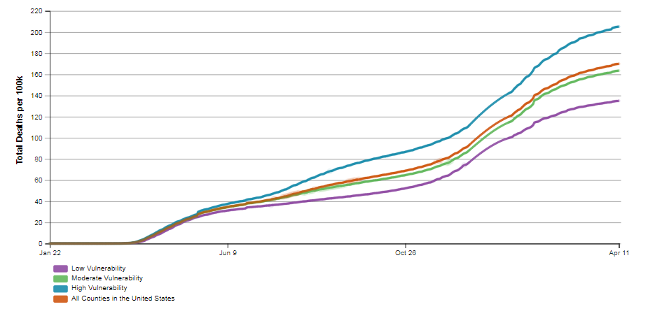
Note. Racism increases risk for other underlying conditions that affect health including socioeconomic status, access to health care, and exposure to the virus related to occupation, e.g., frontline, essential, and critical infrastructure workers. Race is a social construct, not biological or genetic.
Figure 1. COVID-19 Cumulative Death Rate per 100,000 Population in United States, by County Social Vulnerability Index Value. (CDC, 2021, April). Social Vulnerability considers factors such as socioeconomic status, household composition, housing type, transportation.
- Describe any trends you notice in Table 1 and Figure 1.

- Name 2-3 social factors that might impact these trends. How do you think each social factor may contribute to increased risk for COVID-19?

Covid-19 Case Study: Laura is a 35-year-old woman and identifies as Latina. She is a single mother of two young children and lives in a multi-family, Spanish-speaking household. During the day, Laura takes the public bus to a local restaurant where she works. Ever since her children’s school closed at the beginning of the pandemic, Laura has struggled to find childcare for her kids while she is at work. After work, Laura usually goes to the public library to use their computers as she does not have one at home, but the library is currently closed due to Covid-19 restrictions. She learned at work today that her co-worker tested positive for Covid-19. Her boss has asked her to take time off work to get a Covid-19 test, although she is an hourly worker and does not qualify for paid sick leave. The closest testing center is 15 miles away from her house.

- Based on what you learned from the previous question and from information provided in the case study, describe Laura’s COVID-19 risks relative to the general public.

- In order to get a Covid-19 test from a testing center, there are multiple steps that an individual must take from finding a testing center (first step) to receiving the physical test (final step). Brainstorm 3-5 steps and reflect on challenges that Laura may face for each step given her situation. Consider the location of the testing center, transportation, language, and other factors that would make access to a testing center more difficult. Illustrate your sequence of events using the provided storyboard template. The first and final step has been done for you. (If you are struggling, watch this video for ideas).

- Based on the challenges you identified in your storyboard, suggest three actions policy makers could take to improve the accessibility of Covid-19 testing centers?

1)

2)

3)

- How might the accessibility of Covid-19 testing centers impact Covid-19 racial health disparities?
Storyboard: Access to Covid-19 Testing Centers

- In order to get a Covid-19 test from a testing center, there are multiple steps that an individual must take from finding a testing center (first step) to receiving the physical test (final step). Brainstorm 3-5 steps and reflect on challenges that Laura may face for each step given her situation. Consider the location of the testing center, transportation, language, and other factors that would make access to a testing center more difficult. Illustrate your sequence of events using the provided storyboard template. The first step has been done for you.

Step 1: Find a Covid-19 testing center. | Step 2: | Step 3:
Challenges: Laura does not have access to a computer at home and the library is currently closed due to the pandemic. | Challenges: | Challenges:
Step 4: | Step 5: | Step 6:
Challenges: | Challenges: | Challenges:
Final step: Laura receives a Covid-19 test.

Take Action Activity

Objective: Write a letter or email to your local government to educate them about a COVID-19 issue that impacts groups that are marginalized by race, ethnicity, primary spoken language, or socioeconomic status. Address the issue and advocate for your proposed solutions.

Why should you write a letter to an elected official?
- Your representative is there to represent you and your community
- They may be unaware about the issue you address
- Your experiences, research, and opinions can help inform them
- Elected officials have power to make changes that help your cause

STEP 1: Research your issue
Find evidence from reliable sources to back up your claims. (Ex: Center for Disease Control (CDC), World Health Organization (WHO), Johns Hopkins Coronavirus Resource Center, State or County Health Departments)

Helpful Search Terms: The following vocabulary may help you with your research
- Health disparity (CDC, 2020) – preventable differences in the burden of disease, injury, violence, or opportunities to achieve optimal health that are experienced by socially disadvantaged populations. Populations can be defined by factors such as race or ethnicity, gender, education or income, disability, geographic location (e.g., rural or urban), or sexual orientation. Health disparities are inequitable and are directly related to the historical and current unequal distribution of social, political, economic, and environmental resources.
- Social determinants of health (CDC, 2021) – conditions in the places where people live, learn, work, and play that affect a wide range of health and quality-of life-risks and outcomes.

STEP 2: Choose a recipient of your letter
You can look up your federal, state, and local officials here: https://www.usa.gov/elected-officials

STEP 3: Write your letter
The template can help you structure your letter. Take a position on an issue and offer your solutions. Remember that kindness goes a long way when you are asking for support.

STEP 4: Send it
Look up your elected official’s contact information. Usually, they will have a website or email where you can send your letter online. Alternatively, you can mail your letter to their office address.

Letter Template to an Elected Official

Elected Official’s Full Name
Elected Official’s Title
Their Address

Today’s date

Dear (Official’s Name),

Explain the purpose of your letter. Who are you? Are you writing as part of a school/organization/group? Why are you writing to your chosen elected official? What is the issue/concern?

Summarize your understanding of the issue. What background or history can you provide on the issue? Do you have evidence or statistics that support your position? Who is affected by the issue? Is there a particular need in the community? Do you have a personal connection to the issue? Do you have a story about the issue?

Describe your proposed solutions. Who will be affected by the changes? What do the changes mean to you? How will the changes improve the issue?

Ask for support. How can the elected official help your identified issue? What actions can they take? Who else can they garner support from?

Thank them. How can you assist them?

Sincerely,

Your Name
Your Contact Information

